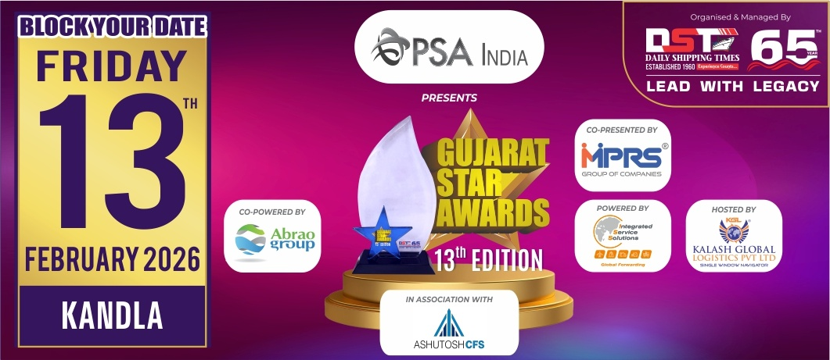
Nomination Form
Information should be relevant to
FY 2024-25 & for Gujarat Region only
(Jury Chairman will disqualify the papers if it is not related to Gujarat)
Note : Please mail back the details on nominations@gujaratstarawards.com

Award Category : BEST FREIGHT FORWARDER OF THE
YEAR - CONTAINERS / MULTICARGO

Award Criteria :-
Volume handled in TEUs for Containerised & in MT for Multicargo, Year on Year Growth, Variety of Cargo handled.
Please Note : Last date for Filing Nomination is 3rd November, 2025

Contact Information :-

Name of the Company :-
Contact Person :-
Designation :-
Contact No. :-
Email Address :-

Volume Handled (April 2024 to March 2025) :-

TEUs for Containerised

MT for Multicargo

Year on Year Growth (Kindly mention figures for Last 3 years & growth percentage) :-

YEAR VOLUME GROWTH %
2024-2025

2023-2024

2022-2023

Variety of Cargo handled :-

